Hello World – eBay API/SDK Tutorial for VB.Net

This tutorial shows the bare minimum to get started with eBay API/SDK. You can find the code used in this tutorial in the Samples/VB.NET/HelloWorld folder of the .NetSDK package.

Prerequisite:
1. eBay Trading SDK for .Net 2.0
2. An eBay user token
3. Visual Studio 2005 (or 2008)

Steps to Create the Hello World Sample:
1. Create a new Visual Basic Console Application called HelloWorld in Visual Studio (see Fig 1).
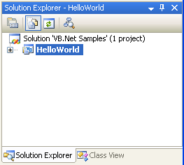
Fig 1. HelloWorld Project

2. Add a new application configuration file (app.config, see Fig. 2) to this project. This file will contain some configuration information such as your eBay user token and the API Server Url, which are necessary for calling an eBay API (see Listing 1). Please update the token value with your own token before you run this sample.

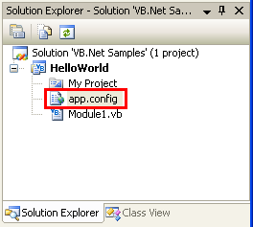
Fig 2. App.config file

<?xml version="1.0" encoding="utf-8" ?>
<configuration>
<appSettings>
<!-- API Server URL, required -->
<!-- For production site use: https://api.ebay.com/wsapi -->
<!-- For Sandbox site use: https://api.sandbox.ebay.com/wsapi -->
<add key="Environment.ApiServerUrl" value="https://api.sandbox.ebay.com/wsapi"/>
<!-- User token for API server access, required -->
<add key="UserAccount.ApiToken" value="you ebay user token"/>
</appSettings>
</configuration>
Listing 1. Content of App.config

3. Add a reference to the eBay.Service assembly(see Fig 3). You will find the assembly in the root folder of your eBay SDK for .Net installation. eBay.Service assembly is the main component of the SDK, and it encapsulates eBay API calls and hides the low level communication details from you. Make sure you also add a reference to the System.configuration .Net assembly.

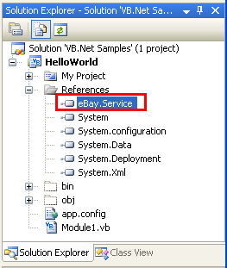
Fig 3. eBay.Service assembly

4. Add the following code (see Listing 2) in the main Module file(see Fig 4)

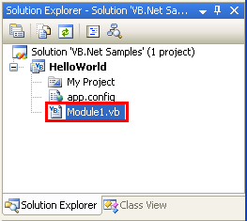
Fig 4. Main Module

Imports System.Configuration
Imports eBay.Service.Call
Imports eBay.Service.Core.Sdk
Imports eBay.Service.Core.Soap

''' <summary>
''' A hello world-like sample
''' showing how to call an eBay API using an eBay SDK
''' </summary>
''' <remarks></remarks>
Module Module1

Private apiContext As ApiContext = Nothing

Sub Main()
Console.WriteLine("+++++++++++++++++++++++++++++++++++++++")
Console.WriteLine("+ Welcome to eBay SDK for .Net Sample +")
Console.WriteLine("+ - HelloWorld +")
Console.WriteLine("+++++++++++++++++++++++++++++++++++++++")

'[Step 1] Initialize eBay ApiContext object
Dim apiContext As ApiContext = GetApiContext()

'[Step 2] Create call object and execute the call
Dim apiCall As GeteBayOfficialTimeCall = New GeteBayOfficialTimeCall(apiContext)
Console.WriteLine("Begin to call eBay API, please wait ...")
Dim officialTime As DateTime = apiCall.GeteBayOfficialTime()
Console.WriteLine("End to call eBay API, show call result:")

'[Step 3] Handle the result returned
Console.WriteLine("eBay official Time: " + officialTime)
Console.WriteLine()
Console.WriteLine("Press any key to close the program.")
Console.ReadKey()

End Sub

''' <summary>
''' Populate eBay SDK ApiContext instance with data from application configuration file
''' </summary>
''' <returns>ApiContext instance</returns>
''' <remarks></remarks>
Private Function GetApiContext() As ApiContext

'apiContext is a singleton
'to avoid duplicate configuration reading
If (apiContext IsNot Nothing) Then
Return apiContext
Else
apiContext = New ApiContext

'set Api Server Url
apiContext.SoapApiServerUrl = _
ConfigurationManager.AppSettings.Get("Environment.ApiServerUrl")
'set Api Token to access eBay Api Server
Dim apiCredential As ApiCredential = New ApiCredential
apiCredential.eBayToken = _
ConfigurationManager.AppSettings.Get("UserAccount.ApiToken")
apiContext.ApiCredential = apiCredential
'set eBay Site target to US
apiContext.Site = SiteCodeType.US

Return apiContext

End If

End Function

End Module

Listing 2. Source Code of the Module

5. Debug the HelloWorld project in Visual Studio. You will see following output in the console window (see Fig 5):
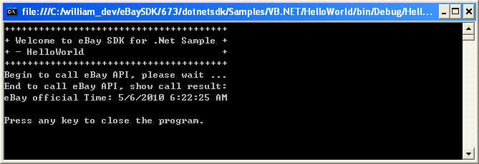
Fig 5. Console Output

This sample calls GeteBayOfficialTime API to get eBay official time. If everything works correctly, you will see eBay official time returned in the output window.
Now you have a working sample which can call an eBay API using an eBay SDK. Congratulations!

Call Flow Analysis

A typical eBay API/SDK call paradigm (see Fig 6) involves three steps. Below is an analysis of each step. Please use the source code listed above (Listing 2) as a reference.

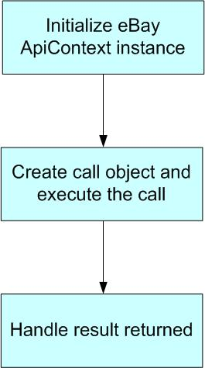
Fig 6. Typical eBay API/SDK Call Paradigm

[Step 1] Initialize eBay ApiContext object

In order to call the eBay API, you need to initialize an ApiContext object first. ApiContext object contains all the configurations and settings that are necessary to call the eBay API.

In the sample, we populate the ApiContext object with a user token and server Url found in the App.config file. We also set Site on the ApiContext object to target the eBay U.S. site.

There are other configurations and settings on the ApiContext object. This sample only shows the bare minimum, so please refer to SDK doc/source for more details.

[Step 2] Create call object and execute the call
For each eBay API call, there is a corresponding wrapper class in the SDK. For example, GeteBayOfficialTimeCall is a wrapper class for the GeteBayOfficialTime API call.

In the sample, we created a new instance of GeteBayOfficialTimeCall wrapper class and then called its GeteBayOfficalTime() method. If the call was successful, a DateTime class instance containing eBay official time was returned.

Because of the wrapper class, you only need to write a few lines of code to talk to eBay servers. The eBay SDK handles the low-level communications with eBay servers for you.

[Step 3] Handle the result returned
After you get the response, you can handle the response according to your own requirements. In the sample, we just output the returned eBay official time in the console.

